Sai Manoj Gunakala

Web Technologies  
MSIS 517L  
April 25, 2017  
   
 Assignment 9

Screen shots of the Assignment 9

1.

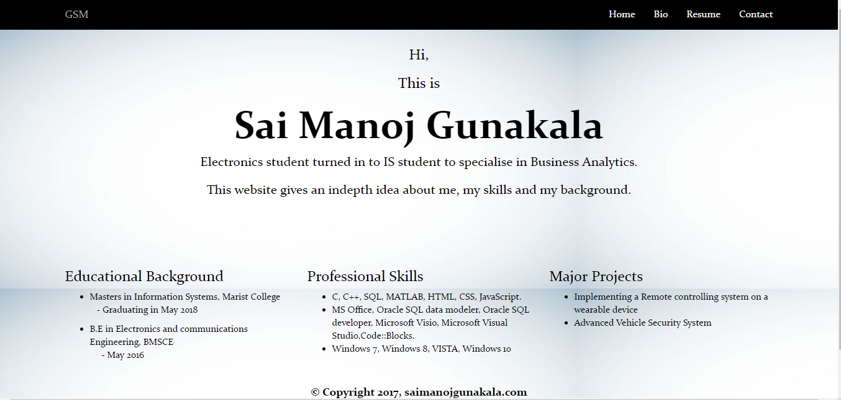

The above screenshot shows the navigation bar, grid on the main page and a part of the footer.

2.

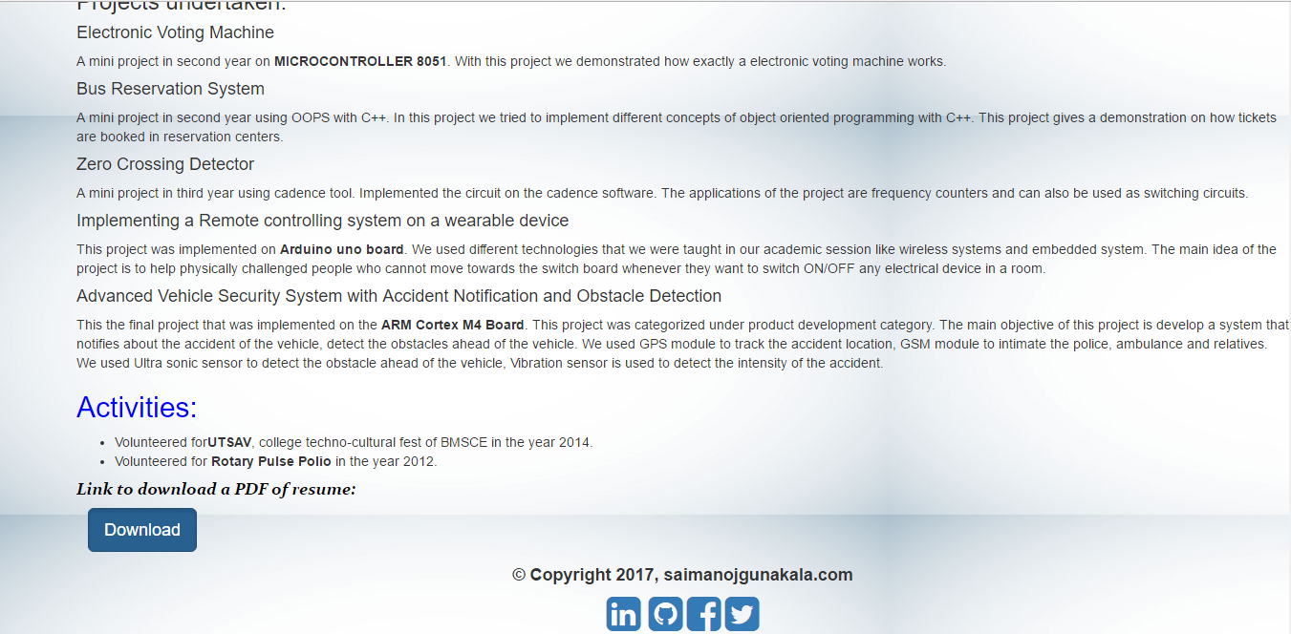

This screenshot provides the button and the footer with links for linkedIn, twitter, facebook and github.